**Quiz for Java Programming** (Tutor: cyd@bupt.edu.cn)

Unit 08 Java Database Programming

1. There is a MySQL database located at 127.0.0.1 with name "Person". Make a new table with 3 fields: "Name" contains string data, "Age" contains numeric data and "marriage" contains bool data. Write down the SQL statements.
2. To remove a table from database, we use the statement
3. Show the data in Quiz 1 which meet the condition that the marriage type is true. Write down the SQL statements
4. Insert a new record into the table in Quiz 1: "Kitty", 13, false Write down the SQL statements

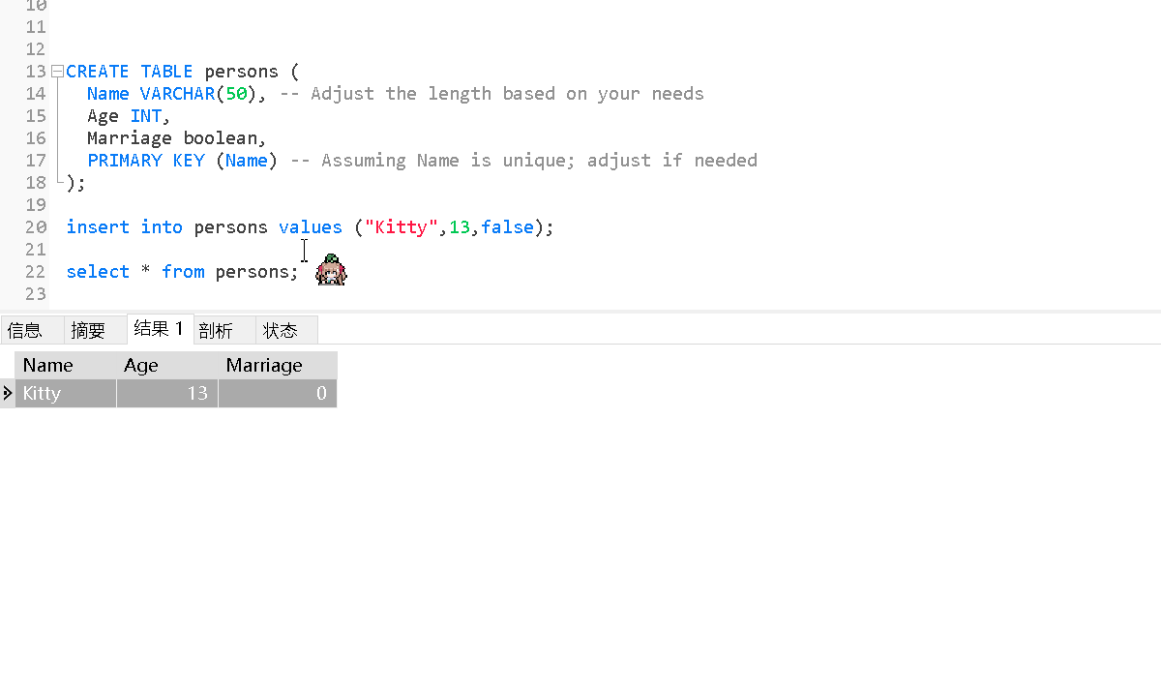

1. Update the record in the table in Quiz 1. Modify "Kitty" to "Hello Kitty". Give the SQL.
2. Write a java program to read all the data in the table in Quiz 1
3. Modify the program in Quiz 6 to do the operation listed in Quiz 4
4. Modify the program in Quiz 7 to do the operation listed in Quiz 5

import java.sql.PreparedStatement**;**import javax.sql.DataSource**;**import org.junit.Test**;**public class psUpdatePerson {  
 @Test  
 public void test() throws Exception {  
 //用Druid连接池 获取指定DataBaseSource(连接操作封装到了druid.properties文件中)  
 DataSource dataSource = DruidUsePart.*getDataSource*()**;** //对dataSource利用preparedStatement进行sql操作  
 //1.获取连接  
 //2.编写sql语句  
 //3.创建preparedStatement对象  
 //4.对占位符进行赋值  
 //5.执行sql语句  
 //6.关闭资源  
  
 Connection connection = dataSource.getConnection()**;** String sql = "update persons set name = ? where name = ?;"**;** PreparedStatement preparedStatement = connection.prepareStatement(sql)**;** preparedStatement.setString(1**,**"Hello Kitty")**;** preparedStatement.setString(2**,**"Kitty")**;** int i = preparedStatement.executeUpdate()**;** if (i > 0){  
 System.*out*.println("更新成功")**;**}  
 else{  
 System.*out*.println("更新失败")**;** }  
 preparedStatement.close()**;** connection.close()**;** }  
  
}

运行结果

